SWE20001 – Development Project 1: Tools and Practices

Pass Task <8.1>

Duy Phuong Nguyen (101204984)

Lab: Friday 2:30pm

Tutor: Huai Liu

Team number: 3

Henry Tran 102075482

Edward Knight 102700043

Duy Phuong Nguyen 101204984

This report summarizes my contributions to the teamwork in Week <8> as well as the tasks I have performed during this week:

* During last week, our team already finished debug the battleship project, so we add more feature to the game. My task was adding more music to the game and make it more interesting. I tried to look at GameResources.cs to find the solution. There is a function name LoadSound and LoadMusic.

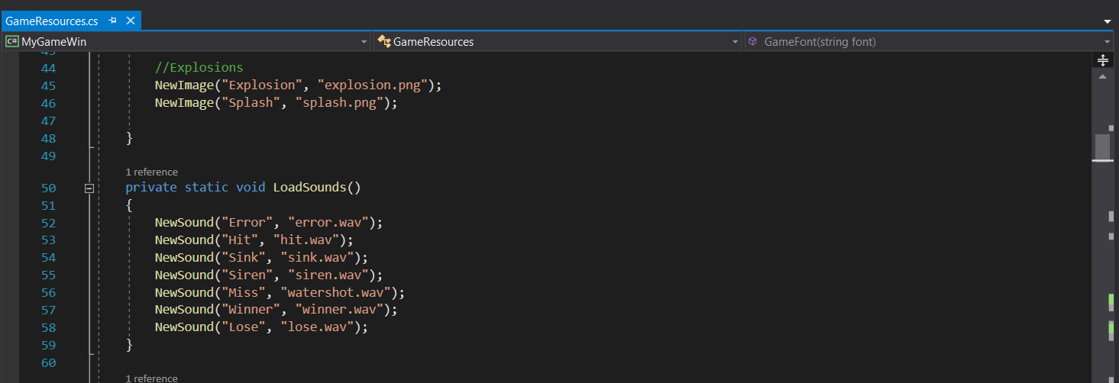

* I put some breakpoint inside the code and run the program again to check how the music function work. However, I realized after reach the main menu, there is no sound or music playing in background.

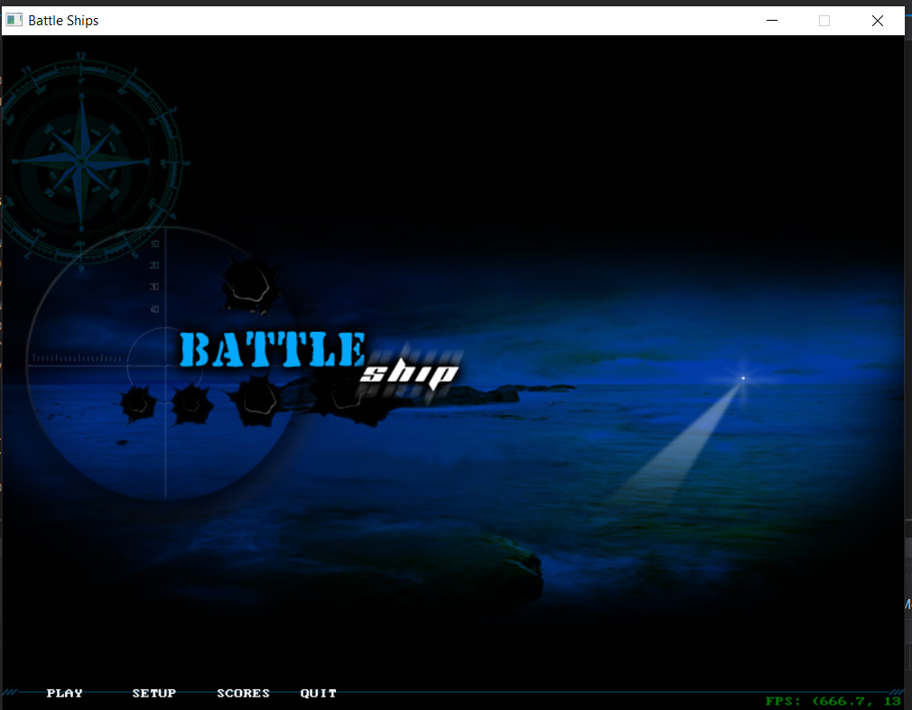

* I tried to fix the bug before adding more music features to the game, but I cannot fix it myself. The background music is not working.
* I tried to inform my teammates and asked for their helps on our discord channel.

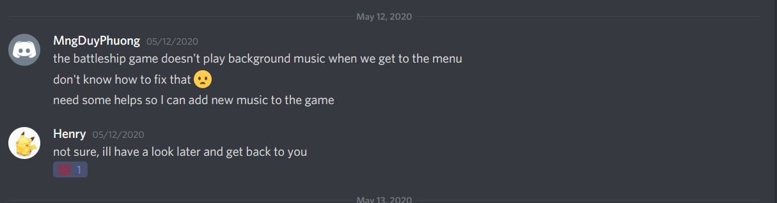

* Henry Tran helped me to solve the problem and he showed me how to fix the bug in the next day. The background music is able to play on his computer.

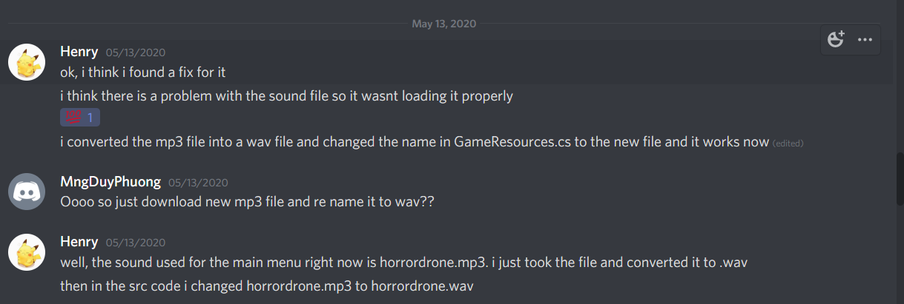

* I followed his instruction to change the horrordrone.mp3 file into wav file using software on the internet. And then rename the music inside source code GameResources.cs

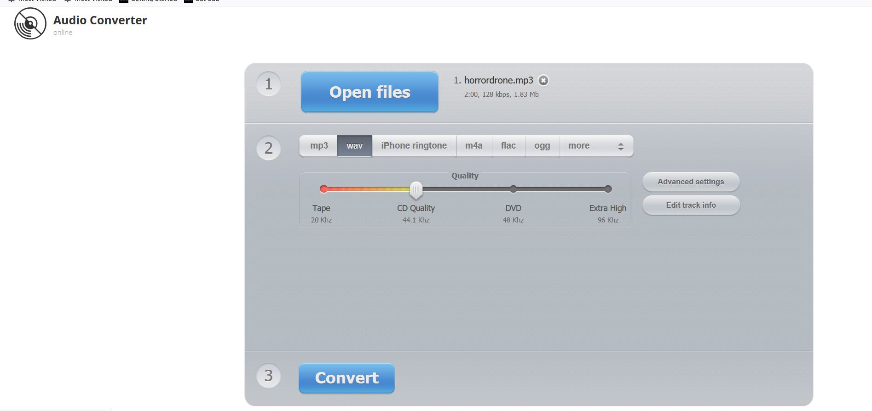

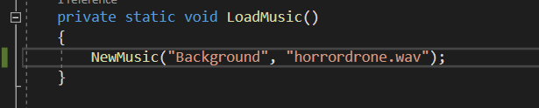

* The project is not working, and the music method is still not playing.



* I asked Henry to send me his file so I can follow and fix my code.

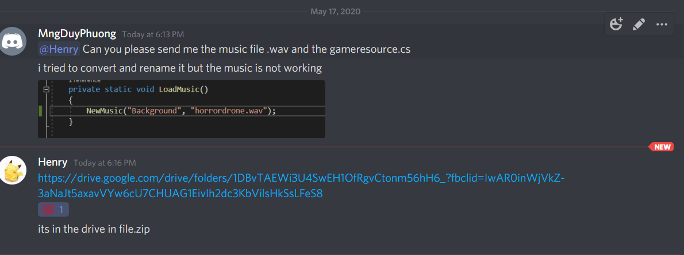

* After download and many fixing steps, the background music is still not able to play on my computer. So, I think there is a different between my Visual studio settings and my teammate’s setting. We cannot go to Uni to use University computer to solve it, and I decided to stop adding music feature to the project.
* **GitHub URL:** [**https://github.com/mngduyphuong/battleship-lab03**](https://github.com/mngduyphuong/battleship-lab03)
* **Trello Board URL:** [**https://trello.com/b/THQg09YT/battleship-code-conversion**](https://trello.com/b/THQg09YT/battleship-code-conversion)